**Chapter 7**

**Parametric Equations and Polar Coordinates**

**7.5 Conic Sections**

**Section Exercises**

**For the following exercises, determine the equation of the parabola using the information given.**

255. Focus  and directrix 

Answer: 

257. Focus and directrix 

Answer: 

259. Focus and directrix 

Answer: 

261. Focus and directrix 

Answer: 

**For the following exercises, determine the equation of the ellipse using the information given.**

263. Endpoints of major axis at  and foci located at 

Answer: 

265. Endpoints of major axis at and foci located at 

Answer: 

267. Endpoints of major axis at and foci located at 

Answer: 

269. Foci located at and eccentricity of 

Answer: 

**For the following exercises, determine the equation of the hyperbola using the information given.**

271. Vertices located at  and foci located at 

Answer: 

273. Endpoints of the conjugate axis located at  and foci located 

Answer: 

275. Vertices located at  and focus located at 

Answer: 

277. Foci located at  and eccentricity of 3

Answer: 

**For the following exercises, consider the following polar equations of conics. Determine the eccentricity and identify the conic.**

279. 

Answer:  parabola

281. 

Answer:  ellipse

283. 

Answer:  hyperbola

**For the following exercises, find a polar equation of the conic with focus at the origin and eccentricity and directrix as given.**

285. 

Answer: 

287. 

Answer: 

**For the following exercises, sketch the graph of each conic.**

289. 

Answer:

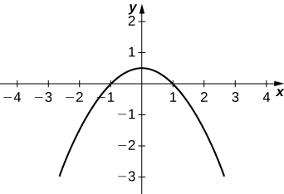

291. 

Answer:

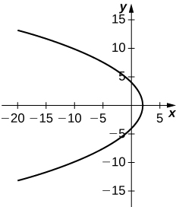

293. 

Answer:

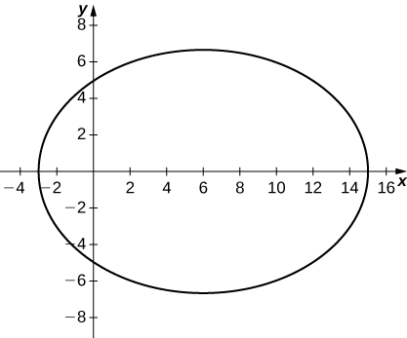

295. 

Answer:

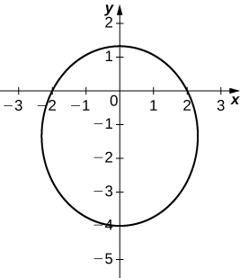

297. 

Answer:

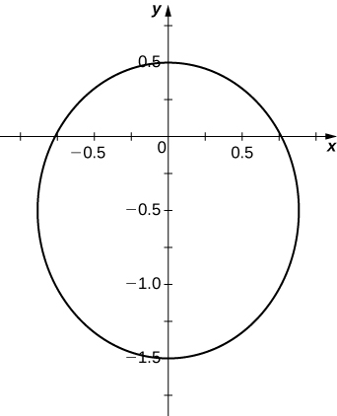

299. 

Answer:

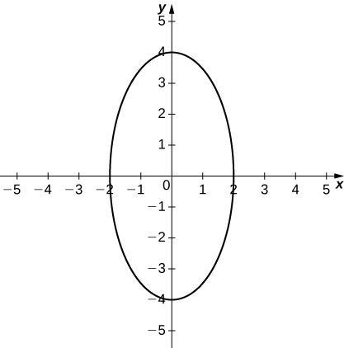

301. 

Answer:

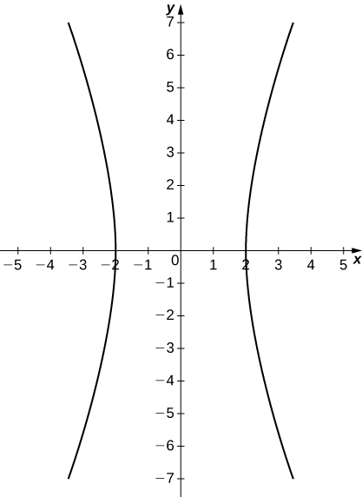

303. 

Answer:

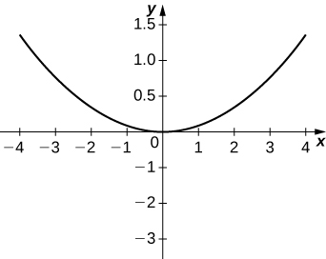

305. 

Answer:

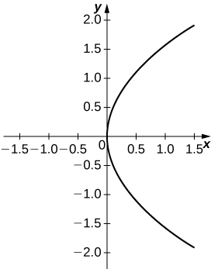

**For the following equations, determine which of the conic sections is described.**

307. 

Answer: Hyperbola

309. 

Answer: Ellipse

311. 

Answer: Ellipse

313. A satellite dish is shaped like a paraboloid of revolution. The receiver is to be located at the focus. If the dish is 12 feet across at its opening and 4 feet deep at its center, where should the receiver be placed?

Answer: At the point 2.25 feet above the vertex.

315. A searchlight is shaped like a paraboloid of revolution. A light source is located 1 foot from the base along the axis of symmetry. If the opening of the searchlight is 3 feet across, find the depth.

Answer: 0.5625 feet

317. A person is standing 8 feet from the nearest wall in a whispering gallery. If that person is at one focus and the other focus is 80 feet away, what is the length and the height at the center of the gallery?

Answer: Length is 96 feet and height is approximately 26.53 feet.

**For the following exercises, determine the polar equation form of the orbit given the length of the major axis and eccentricity for the orbits of the comets or planets. Distance is given in astronomical units (AU).**

319. Hale-Bopp Comet: length of major axis = 525.91, eccentricity = 0.995

Answer: 

321. Jupiter: length of major axis = 10.408, eccentricity = 0.0484

Answer: 

**Chapter Review Exercises**

***True or False*. Justify your answer with a proof or a counterexample.**

323. The equations   represent a hyperbola.

Answer: True.

325. Given  and  if  then  where C is a constant.

Answer: False. Imagine  

**For the following exercises, sketch the parametric curve and eliminate the parameter to find the Cartesian equation of the curve.**

327.   

Answer:

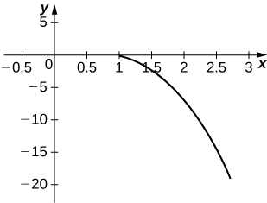



329.   

Answer:

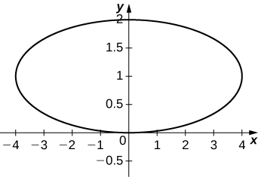



**For the following exercises, sketch the polar curve and determine what type of symmetry exists, if any.**

331. 

Answer:

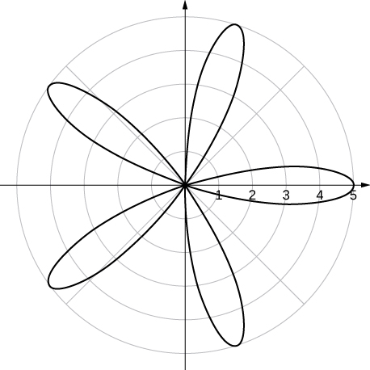

Symmetric about polar axis

**For the following exercises, find the polar equation for the curve given as a Cartesian equation.**

333. 

Answer: 

**For the following exercises, find the equation of the tangent line to the given curve. Graph both the function and its tangent line.**

335.  

Answer: 

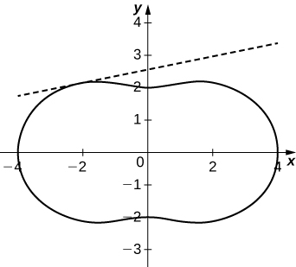

**For the following exercises, find the area of the region.**

337.   

Answer: 

**For the following exercises, find the arc length of the curve over the given interval.**

339.   

Answer: 

**For the following exercises, find the Cartesian equation describing the given shapes.**

341. A parabola with focus  and directrix 

Answer: 

343. A hyperbola with vertices at  and  and foci at  and 

Answer: 

**For the following exercises, determine the eccentricity and identify the conic. Sketch the conic.**

345. 

Answer: , ellipse

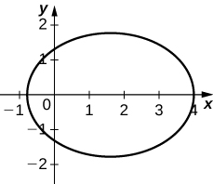

347. Determine the Cartesian equation describing the orbit of Pluto, the most eccentric orbit around the Sun. The length of the major axis is 39.26 AU and minor axis is 38.07 AU. What is the eccentricity?

Answer:  

This file is copyright 2016, Rice University. All Rights Reserved.